**LiqPay**

**Added 08.08.2017.**

Steps.

**Step 1:**

Goto [www.liqpay.ua/en](http://www.liqpay.ua/en)

and click Sign Up button.

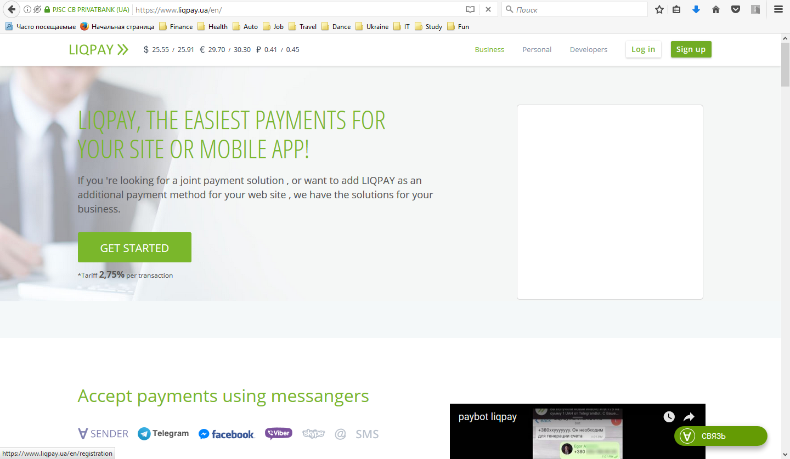

**Step 2:**

Goto [www.liqpay.ua/en](http://www.liqpay.ua/en)/registration

fill in your mobile phone number as a login and click Sign Up.

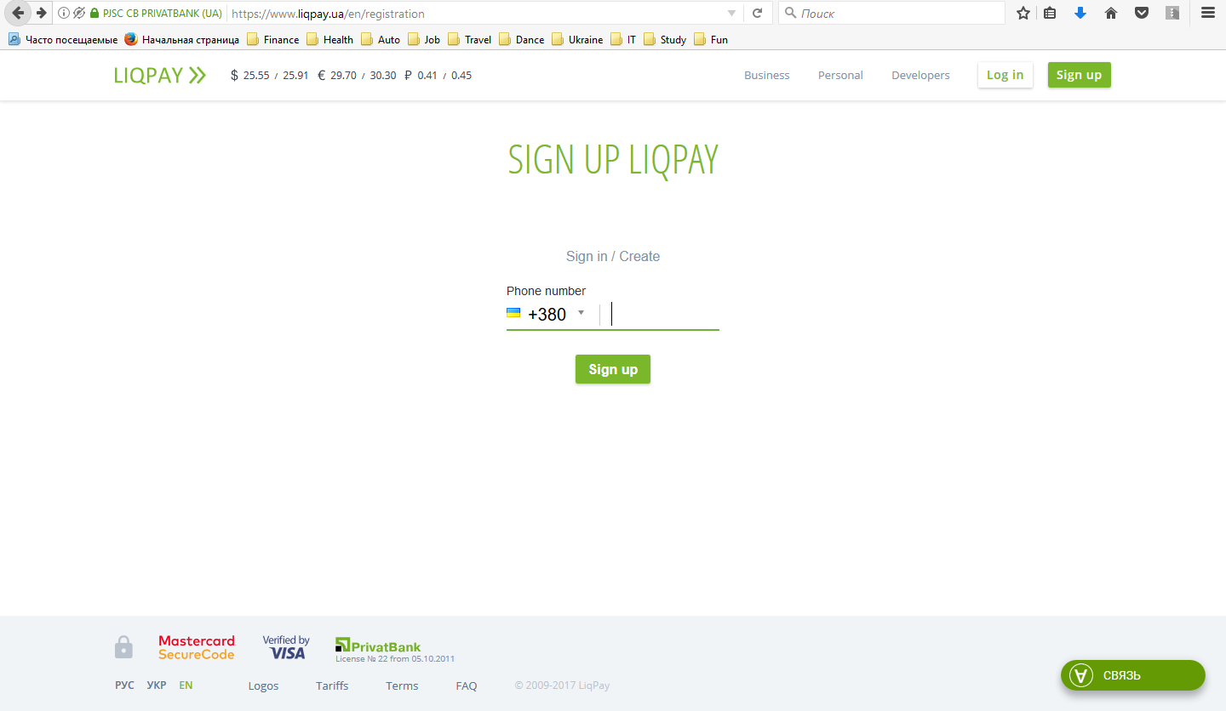

**Step 3:**

Wait for SMS with a password, fill in the password and click Confirm.

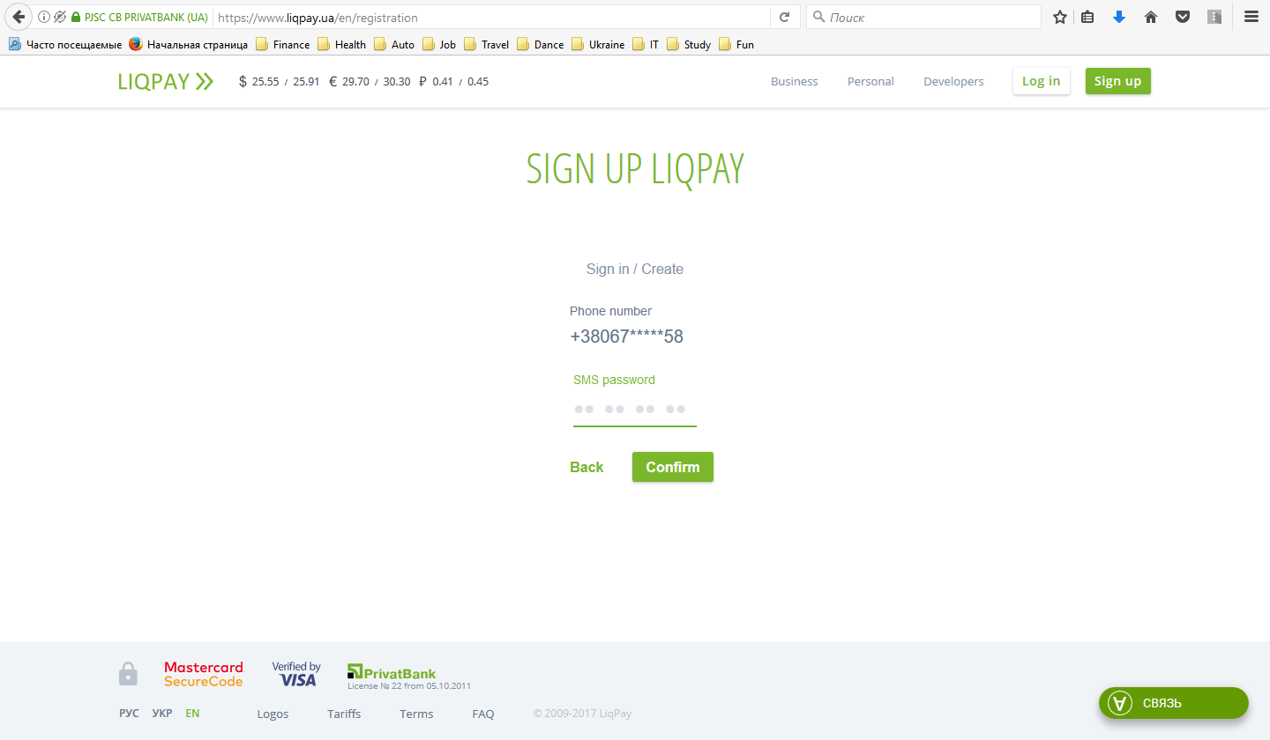

**Step 4:**

Wait for SMS with a password, fill in the password and click Confirm.